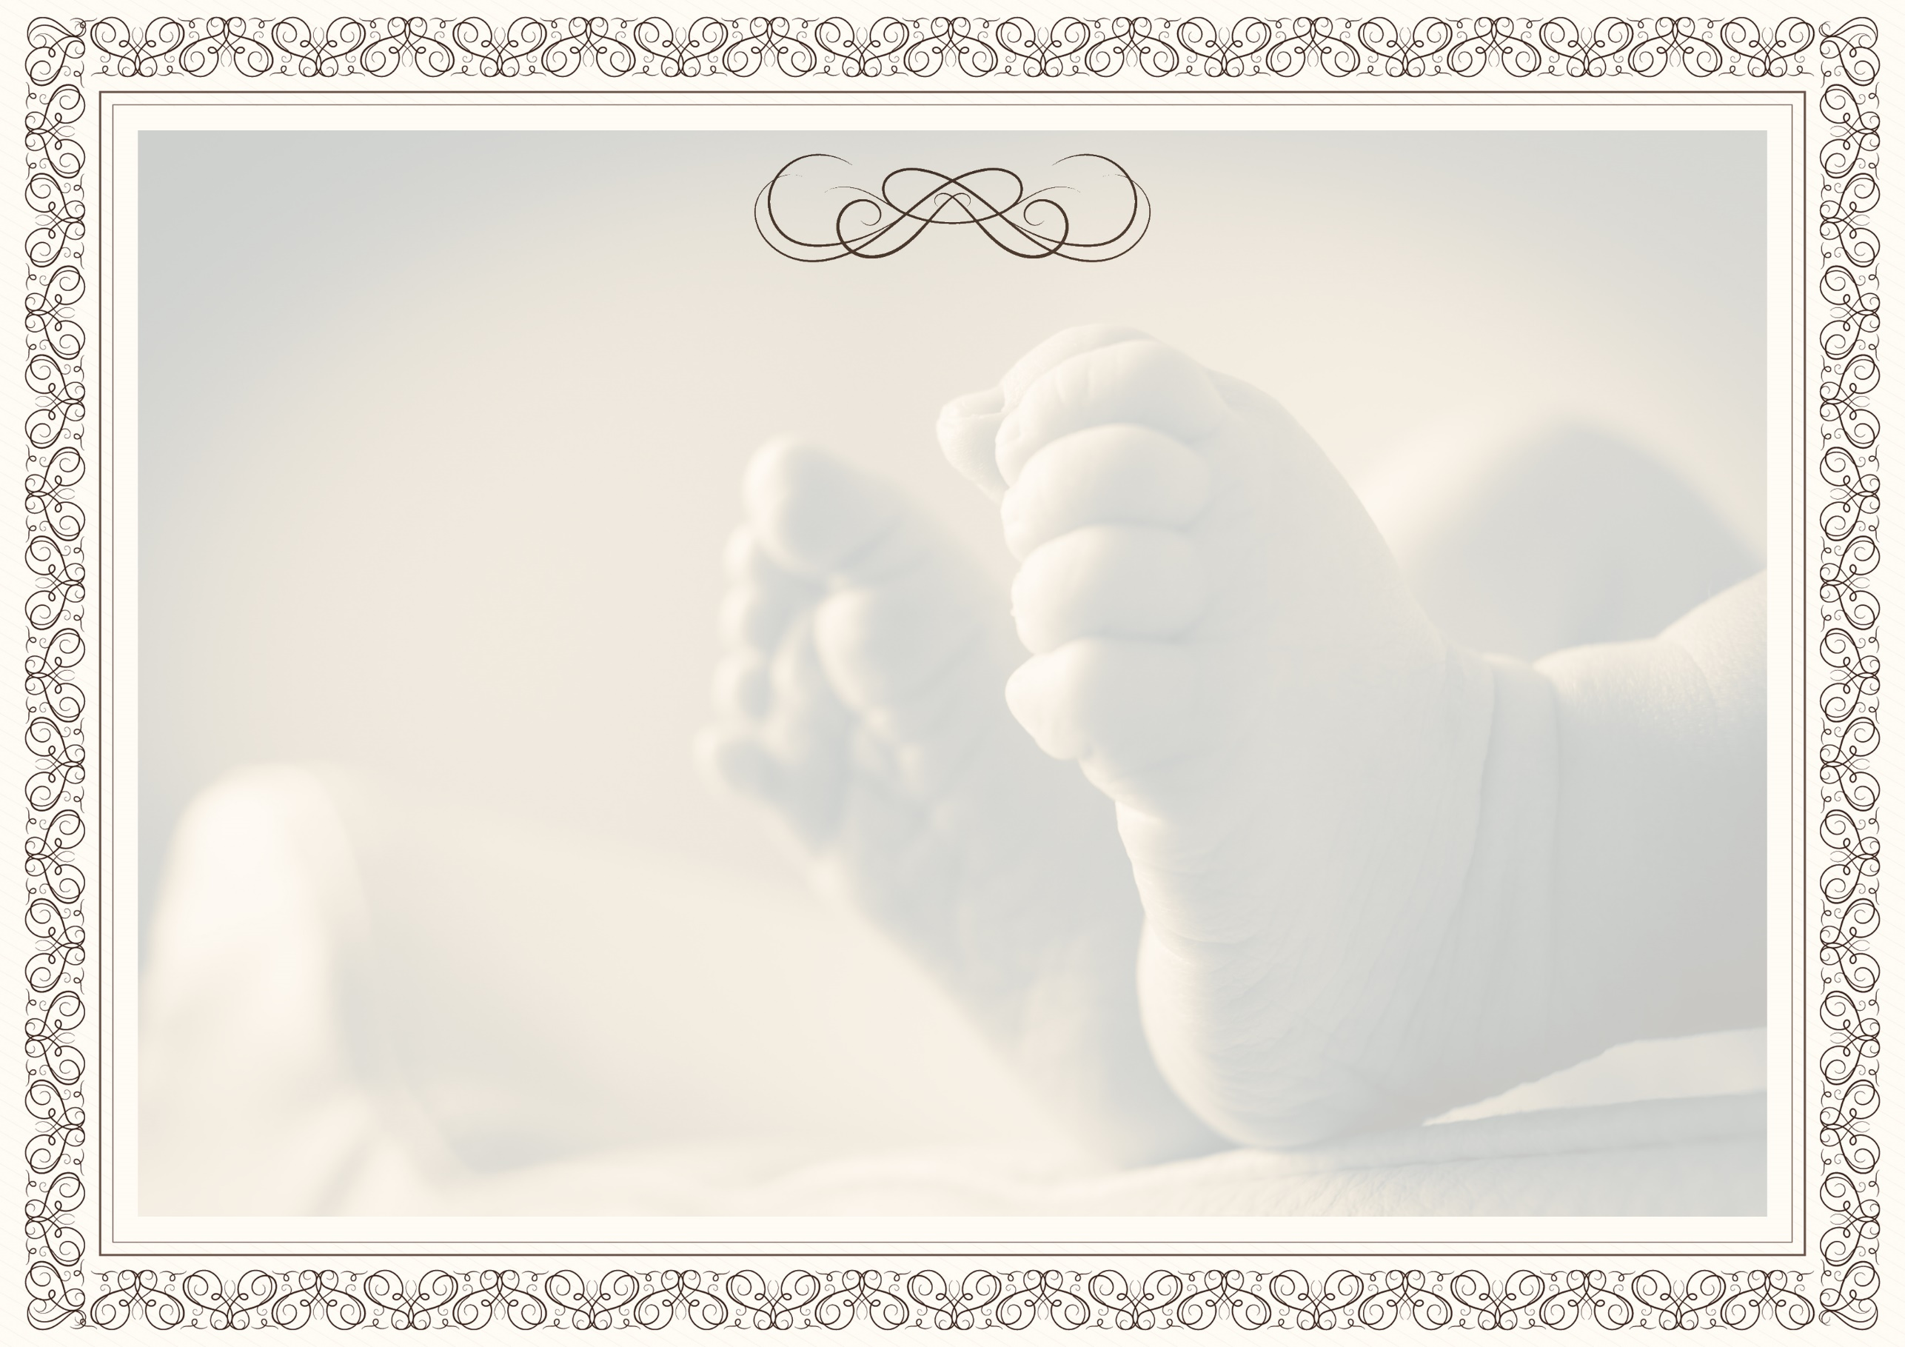

Ninong & Ninang

Cristita Salas
Dianara Lumimbay
Robella Sandilan
Genelda Lumimbay
Jecil Rojas
Ariana Acebido
Algen Banuelos

Jay Cris Mailid
Ronie Cusong
Artchie Bernades
Ricar Cusong
Jeselito Cusong
Jesreel Buag
Jimmy Lopez

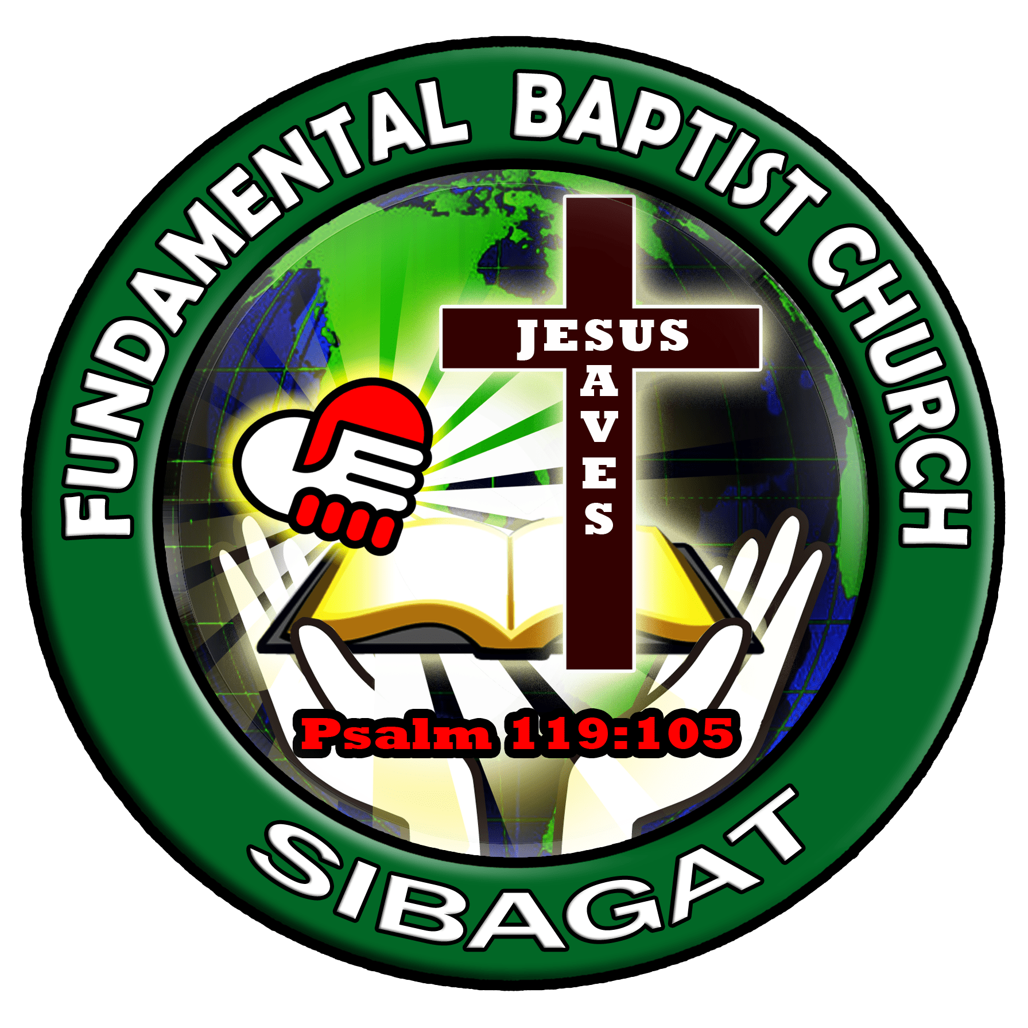
"Children are a heritage from the Lord, offspring a reward from him.".
Psalm 127:3

